**Q1. Write a program that accepts a String with “Betty got a bit of bitter**

**better butter” and perform the**

**following operations:**

**a. Print all the occurrences (index) of “b” and “t” in the string.**

**b. Print each word along with its length in a new line.**

**c. Print all the words that start with “b” in the string.**

**// SOURCE CODE**

public class StrOps {

public static void main(String[] args) {

String text = "Betty got a bit of bitter better butter";

// Part (a): Print all occurrences (index) of 'b' and 't'

System.out.println("Part (a): Indexes of 'b' and 't'");

for (int i = 0; i < text.length(); i++) {

char c = Character.toLowerCase(text.charAt(i));

if (c == 'b') {

System.out.println("'b' found at index " + i);

}

if (c == 't') {

System.out.println("'t' found at index " + i);

}

}

// Part (b): Print each word with its length

System.out.println("\nPart (b): Each word with its length");

String[] words = text.split(" ");

for (String word : words) {

System.out.println(word + ": " + word.length());

}

// Part (c): Print all words starting with 'b'

System.out.println("\nPart (c): Words starting with 'b'");

for (String word : words) {

if (word.toLowerCase().startsWith("b")) {

System.out.println(word);

}

}

}

}

**// OUTPUT :**

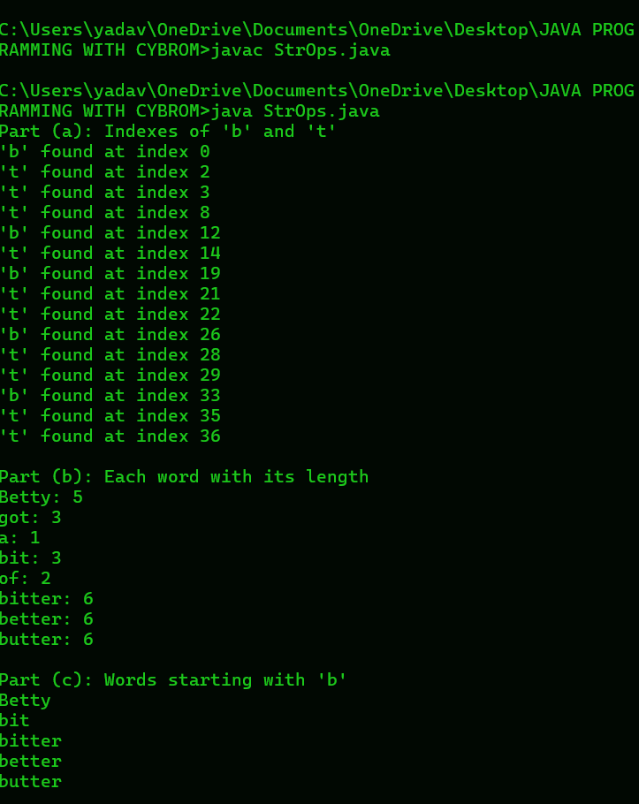

**Q2. Write a program that accept a string and check for following:**

**a. The string should have at least 3 characters.**

**b. The string should not have any special characters or digits except**

**alphabets.**

**If any of the condition does not matches appropriate error message**

**should be displayed.**

**// SOURCE CODE**

import java.util.Scanner;

public class StringValidation {

public static void main(String[] args) {

Scanner scanner = new Scanner(System.in);

System.out.print("Enter a string: ");

String input = scanner.nextLine();

if (input.length() < 3) {

System.out.println("Error: The string must have at least 3 characters.");

} else if (!input.matches("[a-zA-Z]+")) {

System.out.println("Error: The string must contain only alphabets.");

} else {

System.out.println("Valid string: " + input);

}

}

}

// **OUTPUT**

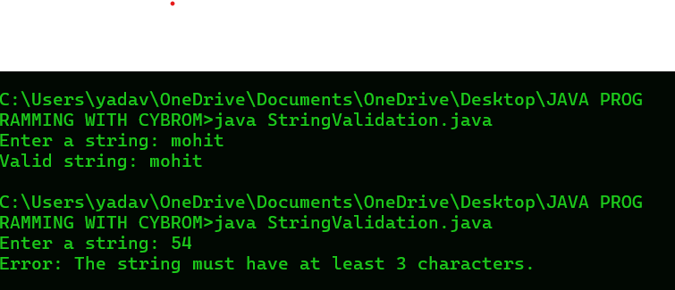

**Q3. Write a program that accept a string and check for following:**

**a. The string should have only 5 characters.**

**b. The string should not have any special characters or alphabets**

**except digits.**

**If any of the condition does not matches appropriate error message**

**should be displayed.**

**// SOURCE CODE**

**import java.util.Scanner;**

**public class StringValidation {**

**public static void main(String[] args) {**

**Scanner scanner = new Scanner(System.in);**

**System.out.print("Enter a string: ");**

**String input = scanner.nextLine();**

**if (input.length() != 5) {**

**System.out.println("Error: The string must have exactly 5 characters.");**

**} else if (!input.matches("[0-9]+")) {**

**System.out.println("Error: The string must contain only digits.");**

**} else {**

**System.out.println("Valid string: " + input);**

**}**

**}**

**}**

**// OUTPUT**

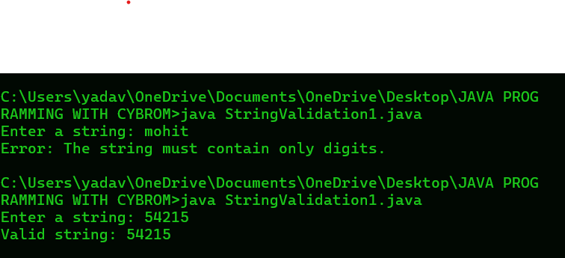

**Q4. Write a program that accepts a string and check for following:**

**a. The string should have at least 6 characters.**

**b. The string should not have any special characters except @.**

**If any of the condition does not matches appropriate error message**

**should be displayed.**

**// SOURCE CODE**

**import java.util.Scanner;**

**public class StringValidation {**

**public static void main(String[] args) {**

**Scanner scanner = new Scanner(System.in);**

**System.out.print("Enter a string: ");**

**String input = scanner.nextLine();**

**if (input.length() < 6) {**

**System.out.println("Error: The string must have at least 6 characters.");**

**} else if (!input.matches("[a-zA-Z0-9@]+")) {**

**System.out.println("Error: The string must not contain special characters except @.");**

**} else {**

**System.out.println("Valid string: " + input);**

**}**

**}**

**}**

**// OUTPUT**

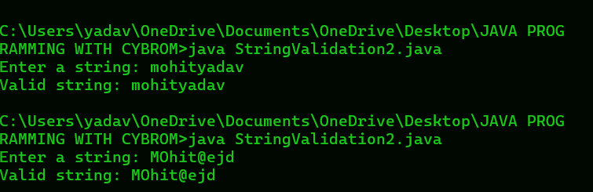

**Q5. Write a program that accepts an array by 10 names and display all**

**names that start with “A”.**

**// SOURCE CODE**

**import java.util.Scanner;**

**public class StringValidation {**

**public static void main(String[] args) {**

**Scanner scanner = new Scanner(System.in);**

**String[] names = new String[10];**

**System.out.println("Enter 10 names:");**

**for (int i = 0; i < 10; i++) {**

**names[i] = scanner.nextLine();**

**}**

**System.out.println("Names starting with 'A':");**

**for (String name : names) {**

**if (name.startsWith("A")) {**

**System.out.println(name);**

**}**

**}**

**}**

**}**

**// OUTPUT**

